### **DATABEAT- ASSIGNMENT1**

**SUBMITTED BY- MADHAV SHARMA(madhavsjk@gmail.com)**

### **Q-1**

1. **Creating EmployeeTable**

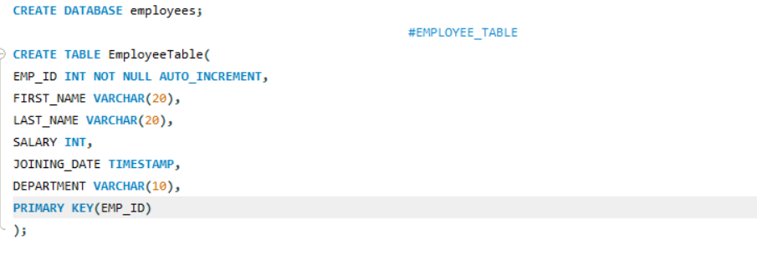

**Inserting Values into EmployeeTable**

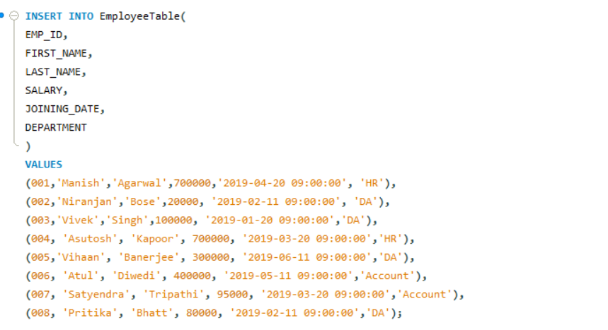

### **Creating VariablesTable**

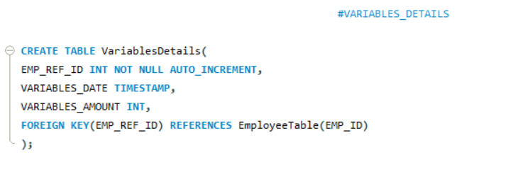

**Inserting into VariablesTables**

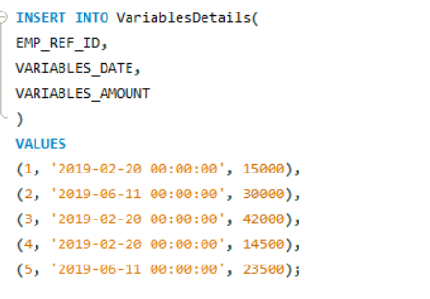

**Creating Designation Table**

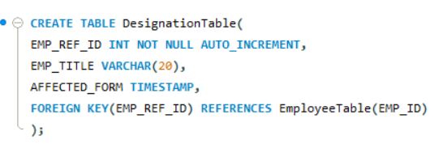

**Inserting into DesignationTable**

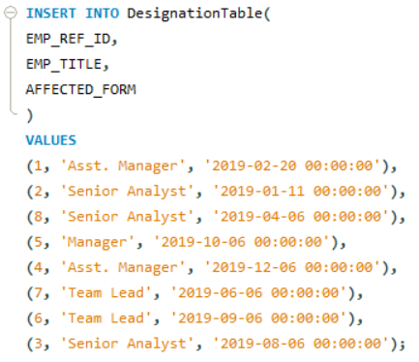

### **Q-2**

### **Ans:**

### Types of Joins in SQL

1. Inner Join: The inner join is used to select all matching rows or columns in both tables or as long as the defined condition is valid in SQL.

Eg.

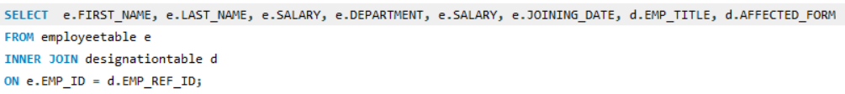

**Output:**

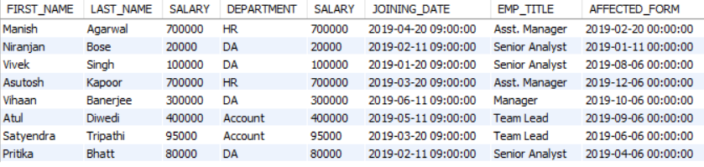

1. Left Join: It is used to retrieve all records from the left table (table1) and the matched rows or columns from the right table (table2). If both tables do not contain any matched rows or columns, it returns the NULL.

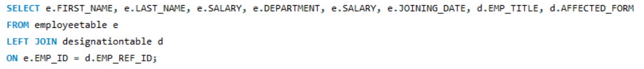

Output:

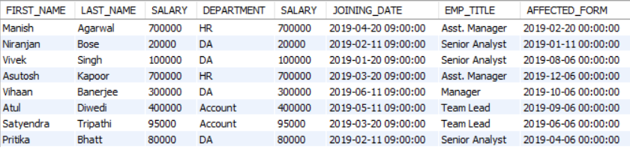

1. Right Join: It is used to retrieve all records from the right table (table2) and the matched rows or columns from the left table (table1). If both tables do not contain any matched rows or columns, it returns the NULL.

E.g:

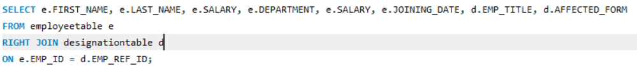

Output:

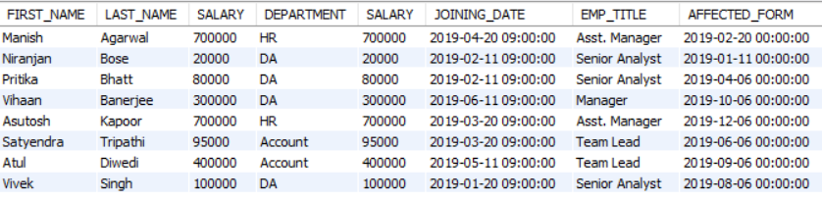

1. Full Join: It is a combination result set of both **LEFT JOIN** and **RIGHT JOIN**. The joined tables return all records from both the tables and if no matches are found in the table, it places NULL. It is also called a **FULL OUTER JOIN**.

E.g

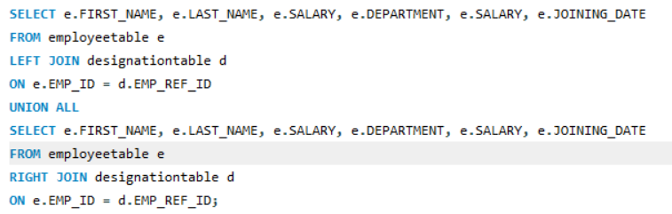

Output:

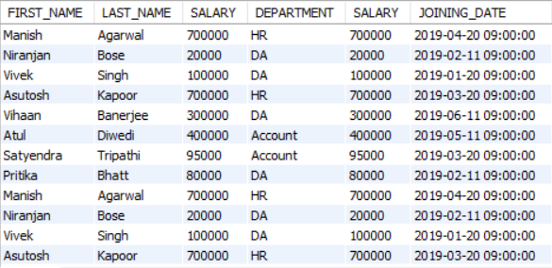

* - - — — – —- – —--- – – – – – — - — - – – - - -

1. Inner Join:

**a) Query with highest variables**

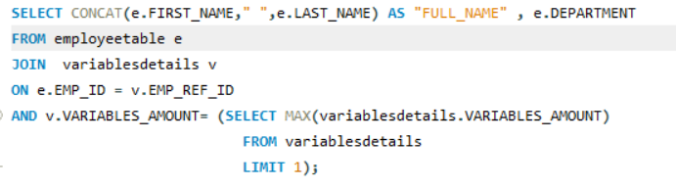

**Query with least variables**

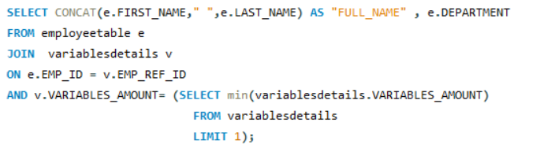

**c)**  The CROSS JOIN keyword returns all records from both tables and produces a result set which is the number of rows in the first table multiplied by the number of rows in the second table if no WHERE clause is used along with CROSS JOIN.

To get item full name, department, joining date, and salary columns from **employeetable** and emp title, affected form columns from **designationtable** , after a CROSS JOINING with these mentioned tables, the following SQL statement can be used:

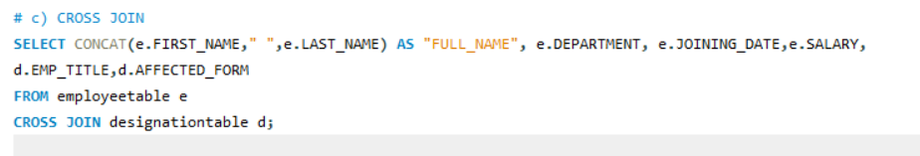

**d)**

d) The SELECT statement has the following clauses:

•SELECT

•FROM

•WHERE

•GROUP BY

•HAVING

•ORDER BY

•OFFSET

•FETCH FIRST

•UNION

•INTERSECT

•EXCEPT

•WITH

Order of execution or preference order:

1. FROM clause
2. ON clause
3. OUTER clause
4. WHERE clause
5. GROUP BY clause
6. HAVING clause
7. SELECT clause
8. DISTINCT clause
9. ORDER BY clause
10. TOP clause

Q3) Ans: Stored procedure: A stored procedure is a series of SQL statements compiled and saved to the database. One of the benefits of stored procedures is that they allow you to store complex scripts on the server.

**a)**

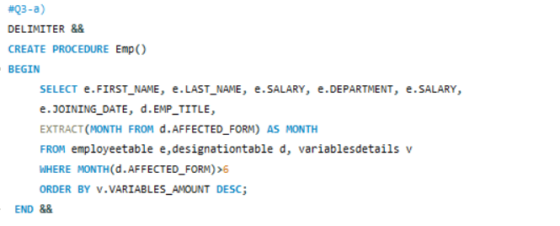

**b)**

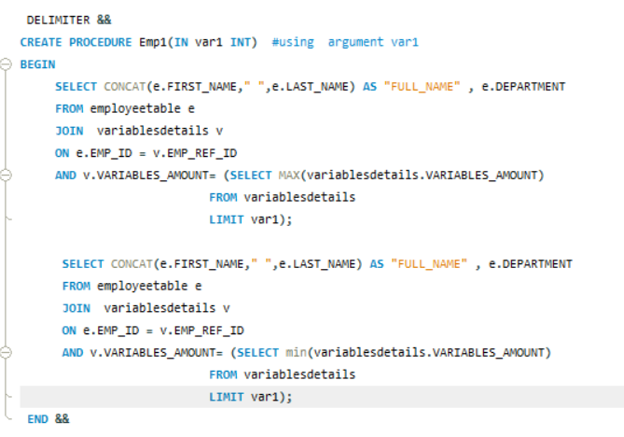

Output:

